PRESS RELEASE

COMMUNICATIONS AND MEDIA TEAM OF THE 43rd ASEAN SUMMIT 2023

No.24/SP/TKM-ASEAN2023/ENG/9/2023

Free Shuttle Service to Media Center for ASEAN Summit Journalists

Jakarta, 1 September 2023 - The organizing committee of the 43rd ASEAN 2023 Summit has prepared free shuttle services serving routes to and from Media Center at the Jakarta Convention Center (JCC) in Jakarta from 5 -7 September 2023.

Provision of the shuttle service is aimed to facilitate movement of journalists covering the 43rd ASEAN Summit to the Media Center. The shuttle service will operate in several routes and serve a number of drop off and pick up points. Meanwhile, the Indonesian National Police (Polri) will also implement traffic engineering measures for smooth traffic flow within the Senayan area of Jakarta.

This was disclosed by the Director-General of Public Information and Communications of the Ministry of Communications and Informatics (Kominfo), Usman Kansong, in Jakarta on Friday, 1 September 2023.

"Vehicle movement is limited due to traffic engineering during the ASEAN Summit. So, we provide shuttle buses that will operate continuously serving several routes to the Media Center," he said.

The shuttle service will serve four routes. Route 1 is serving drop-off/pickup points at Best Western Hotel Senayan, Hotel Century, Hotel Mulia Senayan, TVRI, Spark, and Hall B JCC. This route operates from 1 – 6 September 2023, from 05:00 AM to 09:30 PM local time.

Route 2 serves the Best Western Hotel Senayan, the Ministry of Education, Culture, Research and Technology (Kemendikbud), Gate 7 GBK, The Sultan Hotel, and Hall B JCC. This route operates from 1- 6 September 2023, from 05:00 AM to 09:30 PM.

Route 3 serves the Blue Line Kominfo from Istora Mandiri MRT Station to Gate 9 GBK. This route operates from 1--6 September 2023, from 05:00 AM to 09:30 PM.

Route 4 serves Soekarno-Hatta Airport,Ritz Carlton Pacific Place, The Langham, Fairmont Hotel, Mulia Hotel, and Best Western Hotel Senayan. This route operates from 31 August to 6 September 2023, from 05:00 AM to 10:00 PM.

A total of 29 road sections will be affected by traffic engineering during the 43rd ASEAN Summit. These road sections include Jl Jenderal Sudirman, Jl MH Thamrin, Jl Gatot Subroto, Jl HR Rasuna Said, and Jl Imam Bonjol, among others. Additionally, Jl HOS Cokroaminoto, Jl Galunggung, Jl RM Margono Djojohadikoesoemo, and Jl KH Mas Mansyur will also be impacted.

Other affected road sections include Jl Karet Pasar Baru Timur V, Jl Karet Pasar Baru Timur II, Jl Karet Pasar Baru Timur III, Jl Prof Dr Satrio Sisi Barat, Jl Kebon Sirih, Jl Wahid Hasyim, and Jl Gerbang Pemuda. Furthermore, Jl Pintu Satu Senayan, Jl Asia Afrika, Jl Sisingamangaraja, Jl Pattimura, Jl Trunojoyo, and Jl Gunawarman.

Traffic engineering measures will also be implemented on Jl Majapahit, Jl Ir Juanda, Jl Veteran III, Jl Medan Merdeka Barat, Lingkar Mega Kuningan, Jl Lingkar SCBD, and Jl Setia Budi Tengah.

Furthermore, the Jakarta Provincial Government has deployed 24 electric Transjakarta buses to serve delegates of the 43rd ASEAN 2023 Summit. These environmentally friendly buses will operate on four specific routes during the meeting of ASEAN heads of state and government with their strategic partners.

This was confirmed by the Head of the Corporate Secretary and Public Relations Division of PT Transjakarta, Apriastini Bakti Bugiansri, in Jakarta on Wednesday, 30 August 2023.

The four specific routes include: First, Senayan Multipurpose Building-MRT Istora Mandiri-Sultan Hotel (Summit Venue), operating from 07:00 AM to 10:00 PM.

Second, Senayan Multipurpose Building-MRT Istora Mandiri-Ritz Carlton Pacific Place (Sideline), operating from 07:00 AM to 07:00 PM. Third, Sultan Hotel (Summit Venue)-Ritz Carlton Pacific Place (ABA Venue), operating from 05:00 PM to 07:00 PM. Fourth, Istora Mandiri MRT Station-JCC Senayan Convention Center, operating from 05:00 AM to 08:00 AM.

All electric buses will operate free of charge. (Toro/Donna/TR/Elvira Inda Sari/PR)

***

For further information, please contact:

Director General of Public Information and Communication, Ministry of Communication and Informatics – Usman Kansong (0816785320).

Find more information at http://asean2023.id, https://infopublik.id/kategori/asean-2023, and https://indonesia.go.id/kategori/ragam-asean-2023

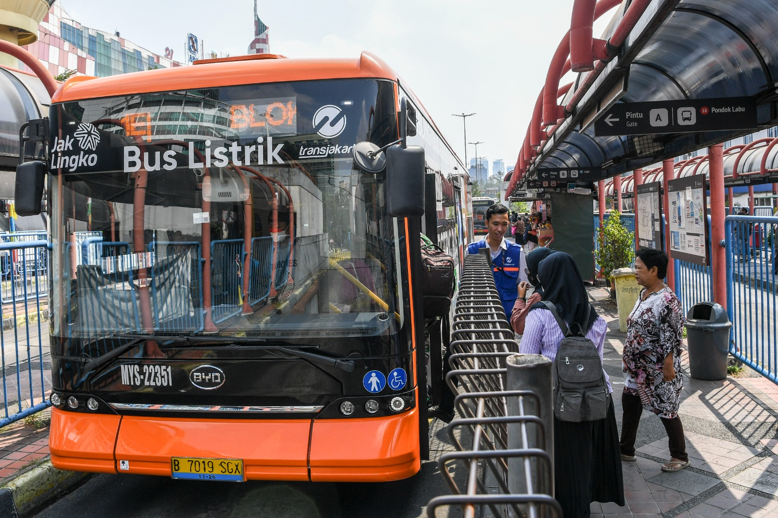

Illustration: Passengers board electric buses at Blok M Terminal, Jakarta, on Thursday (24/8/2023). PT Transportasi Jakarta (Transjakarta) has put into operation a total of 54 electric buses and aims to increase the number to 100 units by the end of 2023 to reduce carbon emissions and as part of efforts to improve air quality in Jakarta. ANTARA FOTO/Galih Pradipta/nym.

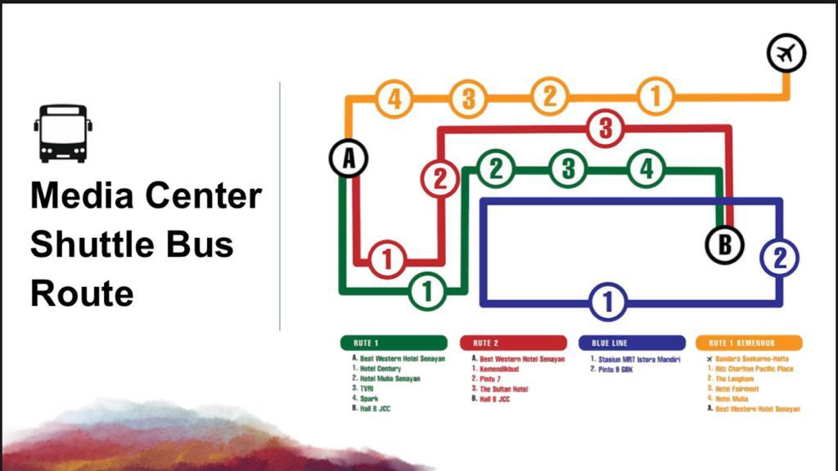

The organizing committee of the 43rd ASEAN Summit 2023 has prepared a free shuttle bus service to the Media Center at the Jakarta Convention Center (JCC), Jakarta, on 5-7 September 2023.

